motivationscore.sav

Step 1: Descriptive Statistic

|  |  |  |  |
| --- | --- | --- | --- |
| Variable |  | Mean (SD) | n (%) |
|  |  |  |  |
| Performance Score | | 79.17 (10.85) |  |
| Teaching Method | PBL |  | 6 (33.3) |
|  | SGD |  | 7 (38.9) |
|  | Lecture |  | 5 (27.8) |
| Motivation Score | | 5.28 (2.14) |  |
|  |  |  |  |

Step 2: Univariable

|  |  |  |  |  |  |  |  |  |
| --- | --- | --- | --- | --- | --- | --- | --- | --- |
| **Descriptives** | | | | | | | | |
| performance score | | | | | | | | |
|  | N | Mean | Std. Deviation | Std. Error | 95% Confidence Interval for Mean | | Minimum | Maximum |
| Lower Bound | Upper Bound |
| PBL | 6 | 67.67 | 4.033 | 1.647 | 63.43 | 71.90 | 62 | 73 |
| SGD | 7 | 79.00 | 3.109 | 1.175 | 76.12 | 81.88 | 75 | 85 |
| Lecture | 5 | 93.20 | 4.550 | 2.035 | 87.55 | 98.85 | 87 | 98 |
| Total | 18 | 79.17 | 10.848 | 2.557 | 73.77 | 84.56 | 62 | 98 |

|  |  |  |  |
| --- | --- | --- | --- |
| **Test of Homogeneity of Variances** | | | |
| performance score | | | |
| Levene Statistic | df1 | df2 | Sig. |
| 1.102 | 2 | 15 | .358 |

Equal Variance

|  |  |  |  |  |  |
| --- | --- | --- | --- | --- | --- |
| **ANOVA** | | | | | |
| performance score | | | | | |
|  | Sum of Squares | df | Mean Square | F | Sig. |
| Between Groups | 1778.367 | 2 | 889.183 | 60.044 | .000 |
| Within Groups | 222.133 | 15 | 14.809 |  |  |
| Total | 2000.500 | 17 |  |  |  |

Significant difference between different teaching method

|  |  |  |  |  |  |  |
| --- | --- | --- | --- | --- | --- | --- |
| **Multiple Comparisons** | | | | | | |
| Dependent Variable: performance score | | | | | | |
| Bonferroni | | | | | | |
| (I) methods | (J) methods | Mean Difference (I-J) | Std. Error | Sig. | 95% Confidence Interval | |
| Lower Bound | Upper Bound |
| PBL | SGD | -11.333* | 2.141 | .000 | -17.10 | -5.57 |
| Lecture | -25.533* | 2.330 | .000 | -31.81 | -19.26 |
| SGD | PBL | 11.333* | 2.141 | .000 | 5.57 | 17.10 |
| Lecture | -14.200* | 2.253 | .000 | -20.27 | -8.13 |
| Lecture | PBL | 25.533* | 2.330 | .000 | 19.26 | 31.81 |
| SGD | 14.200* | 2.253 | .000 | 8.13 | 20.27 |
| *. The mean difference is significant at the 0.05 level. | | | | | | |

Step 3: Main Effect

|  |  |  |  |  |  |
| --- | --- | --- | --- | --- | --- |
| **Tests of Between-Subjects Effects** | | | | | |
| Dependent Variable: performance score | | | | | |
| Source | Type III Sum of Squares | df | Mean Square | F | Sig. |
| Corrected Model | 1778.436a | 3 | 592.812 | 37.374 | .000 |
| Intercept | 12761.119 | 1 | 12761.119 | 804.524 | .000 |
| methods | 1756.600 | 2 | 878.300 | 55.372 | .000 |
| motivation | .069 | 1 | .069 | .004 | .948 |
| Error | 222.064 | 14 | 15.862 |  |  |
| Total | 114813.000 | 18 |  |  |  |
| Corrected Total | 2000.500 | 17 |  |  |  |
| a. R Squared = .889 (Adjusted R Squared = .865) | | | | | |

Teaching method is significant when adjusted to motivation

Step 4: Interaction

|  |  |  |  |  |  |
| --- | --- | --- | --- | --- | --- |
| **Tests of Between-Subjects Effects** | | | | | |
| Dependent Variable: performance score | | | | | |
| Source | Type III Sum of Squares | df | Mean Square | F | Sig. |
| Corrected Model | 1921.031a | 5 | 384.206 | 58.016 | .000 |
| Intercept | 11753.424 | 1 | 11753.424 | 1774.801 | .000 |
| methods | 2.449 | 2 | 1.224 | .185 | .834 |
| motivation | .752 | 1 | .752 | .113 | .742 |
| methods * motivation | 142.595 | 2 | 71.298 | 10.766 | .002 |
| Error | 79.469 | 12 | 6.622 |  |  |
| Total | 114813.000 | 18 |  |  |  |
| Corrected Total | 2000.500 | 17 |  |  |  |
| a. R Squared = .960 (Adjusted R Squared = .944) | | | | | |

Interaction was significant.

Assumption for homogeneity was violated

Step 5: Model Assumption

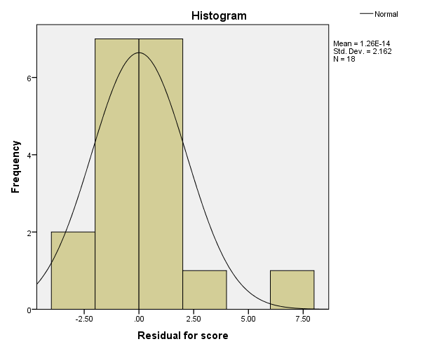

Residual was normally distributed. Assumption for normality (i.e. for each X, there is subpopulation of Y that is normally distributed), is met.

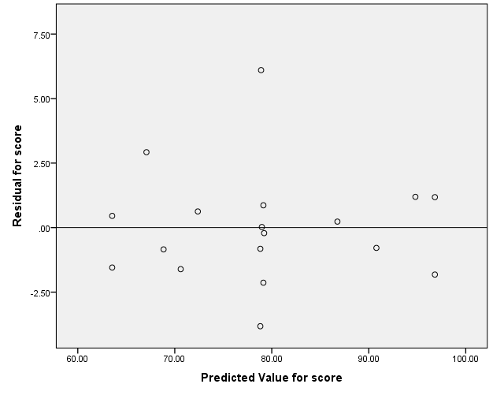

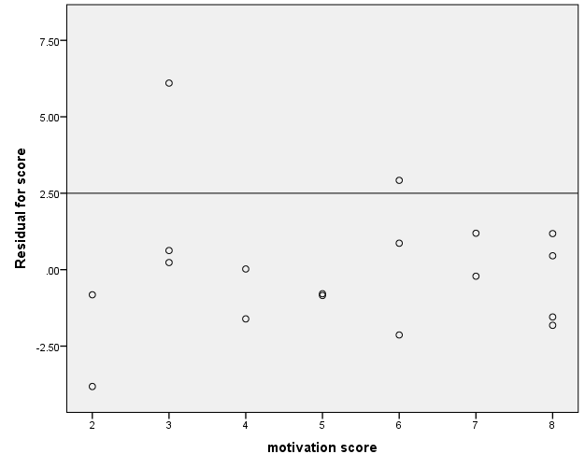

The model had equal variance. It also had equal variance at covariate. Equal variance and linearity assumption were met.

Step 6: Post Hoc Test

Since the homogeneity of variance assumption was violated, 3 point from covariate will be selected and for each point of covariate, main effect model will be developed.

1. Low Motivation: Mean – SD = 5.28 – 2.14 = 3.14

|  |  |  |  |  |
| --- | --- | --- | --- | --- |
| **Estimates** | | | | |
| Dependent Variable: performance score | | | | |
| methods | Mean | Std. Error | 95% Confidence Interval | |
| Lower Bound | Upper Bound |
| PBL | 72.128a | 1.757 | 68.301 | 75.955 |
| SGD | 78.910a | 1.135 | 76.437 | 81.383 |
| Lecture | 87.047a | 2.150 | 82.363 | 91.732 |
| a. Covariates appearing in the model are evaluated at the following values: motivation score = 3. | | | | |

|  |  |  |  |  |  |  |
| --- | --- | --- | --- | --- | --- | --- |
| **Pairwise Comparisons** | | | | | | |
| Dependent Variable: performance score | | | | | | |
| (I) methods | (J) methods | Mean Difference (I-J) | Std. Error | Sig.b | 95% Confidence Interval for Differenceb | |
| Lower Bound | Upper Bound |
| PBL | SGD | -6.782* | 2.091 | .021 | -12.595 | -.969 |
| Lecture | -14.920* | 2.776 | .001 | -22.637 | -7.203 |
| SGD | PBL | 6.782* | 2.091 | .021 | .969 | 12.595 |
| Lecture | -8.138* | 2.431 | .017 | -14.895 | -1.380 |
| Lecture | PBL | 14.920* | 2.776 | .001 | 7.203 | 22.637 |
| SGD | 8.138* | 2.431 | .017 | 1.380 | 14.895 |
| Based on estimated marginal means | | | | | | |
| *. The mean difference is significant at the .05 level. | | | | | | |
| b. Adjustment for multiple comparisons: Bonferroni. | | | | | | |

|  |  |  |  |  |  |  |
| --- | --- | --- | --- | --- | --- | --- |
| **Univariate Tests** | | | | | | |
| Dependent Variable: performance score | | | | | | |
|  | Sum of Squares | df | Mean Square | F | Sig. | Partial Eta Squared |
| Contrast | 192.621 | 2 | 96.310 | 14.543 | .001 | .708 |
| Error | 79.469 | 12 | 6.622 |  |  |  |
| The F tests the effect of methods. This test is based on the linearly independent pairwise comparisons among the estimated marginal means. | | | | | | |

1. at Motivation = Mean

|  |  |  |  |  |
| --- | --- | --- | --- | --- |
| **Estimates** | | | | |
| Dependent Variable: performance score | | | | |
| methods | Mean | Std. Error | 95% Confidence Interval | |
| Lower Bound | Upper Bound |
| PBL | 68.353a | 1.073 | 66.016 | 70.691 |
| SGD | 79.078a | 1.097 | 76.689 | 81.467 |
| Lecture | 91.346a | 1.274 | 88.569 | 94.122 |
| a. Covariates appearing in the model are evaluated at the following values: motivation score = 5.28. | | | | |

|  |  |  |  |  |  |  |
| --- | --- | --- | --- | --- | --- | --- |
| **Pairwise Comparisons** | | | | | | |
| Dependent Variable: performance score | | | | | | |
| (I) methods | (J) methods | Mean Difference (I-J) | Std. Error | Sig.b | 95% Confidence Interval for Differenceb | |
| Lower Bound | Upper Bound |
| PBL | SGD | -10.725* | 1.534 | .000 | -14.988 | -6.461 |
| Lecture | -22.992* | 1.666 | .000 | -27.622 | -18.363 |
| SGD | PBL | 10.725* | 1.534 | .000 | 6.461 | 14.988 |
| Lecture | -12.268* | 1.681 | .000 | -16.941 | -7.595 |
| Lecture | PBL | 22.992* | 1.666 | .000 | 18.363 | 27.622 |
| SGD | 12.268* | 1.681 | .000 | 7.595 | 16.941 |
| Based on estimated marginal means | | | | | | |
| *. The mean difference is significant at the .05 level. | | | | | | |
| b. Adjustment for multiple comparisons: Bonferroni. | | | | | | |

|  |  |  |  |  |  |  |
| --- | --- | --- | --- | --- | --- | --- |
| **Univariate Tests** | | | | | | |
| Dependent Variable: performance score | | | | | | |
|  | Sum of Squares | df | Mean Square | F | Sig. | Partial Eta Squared |
| Contrast | 1266.714 | 2 | 633.357 | 95.639 | .000 | .941 |
| Error | 79.469 | 12 | 6.622 |  |  |  |
| The F tests the effect of methods. This test is based on the linearly independent pairwise comparisons among the estimated marginal means. | | | | | | |

1. at high motivation: 5.28 + 2.14 = 7.42

|  |  |  |  |  |
| --- | --- | --- | --- | --- |
| **Estimates** | | | | |
| Dependent Variable: performance score | | | | |
| methods | Mean | Std. Error | 95% Confidence Interval | |
| Lower Bound | Upper Bound |
| PBL | 64.571a | 1.435 | 61.445 | 67.697 |
| SGD | 79.247a | 1.872 | 75.168 | 83.325 |
| Lecture | 95.653a | 1.360 | 92.690 | 98.616 |
| a. Covariates appearing in the model are evaluated at the following values: motivation score = 7. | | | | |

|  |  |  |  |  |  |  |
| --- | --- | --- | --- | --- | --- | --- |
| **Pairwise Comparisons** | | | | | | |
| Dependent Variable: performance score | | | | | | |
| (I) methods | (J) methods | Mean Difference (I-J) | Std. Error | Sig.b | 95% Confidence Interval for Differenceb | |
| Lower Bound | Upper Bound |
| PBL | SGD | -14.676* | 2.358 | .000 | -21.231 | -8.120 |
| Lecture | -31.082* | 1.977 | .000 | -36.576 | -25.588 |
| SGD | PBL | 14.676* | 2.358 | .000 | 8.120 | 21.231 |
| Lecture | -16.406* | 2.314 | .000 | -22.837 | -9.976 |
| Lecture | PBL | 31.082* | 1.977 | .000 | 25.588 | 36.576 |
| SGD | 16.406* | 2.314 | .000 | 9.976 | 22.837 |
| Based on estimated marginal means | | | | | | |
| *. The mean difference is significant at the .05 level. | | | | | | |
| b. Adjustment for multiple comparisons: Bonferroni. | | | | | | |

|  |  |  |  |  |  |  |
| --- | --- | --- | --- | --- | --- | --- |
| **Univariate Tests** | | | | | | |
| Dependent Variable: performance score | | | | | | |
|  | Sum of Squares | df | Mean Square | F | Sig. | Partial Eta Squared |
| Contrast | 1641.878 | 2 | 820.939 | 123.964 | .000 | .954 |
| Error | 79.469 | 12 | 6.622 |  |  |  |
| The F tests the effect of methods. This test is based on the linearly independent pairwise comparisons among the estimated marginal means. | | | | | | |

Step 7: Presentation

Table : Descriptive Statistic

|  |  |  |  |  |  |  |
| --- | --- | --- | --- | --- | --- | --- |
|  |  |  | Performance Score | | | |
|  |  | n | Observed Mean | SD | Mean Difference | 95% CI |
|  |  |  |  |  |  |  |
| Teaching Method | |  |  |  |  |  |
|  | PBL | 6 | 67.67 | 4.03 |  |  |
|  | SGD | 7 | 79.00 | 3.11 |  |  |
|  | Lecture | 5 | 93.20 | 4.55 |  |  |
|  |  |  |  |  |  |  |

Table : ANCOVA Summary

|  |  |  |  |  |  |  |
| --- | --- | --- | --- | --- | --- | --- |
| Source | SS | df | MS | F-Stat | p-value | Effect Size (η2) |
|  |  |  |  |  |  |  |
| Teaching Method | 2.45 | 2 | 1.22 | 0.185 | 0.834 | 0.03 |
| Motivation | 0.75 | 1 | 0.75 | 0.113 | 0.742 | 0.01 |
| Teaching Method * Motivation | 142.60 | 2 | 71.30 | 10.766 | 0.002 | 0.642 |
| Error | 79.47 | 12 | 6.62 |  |  |  |
|  |  |  |  |  |  |  |
| R2 = 0.960; Adj. R2 = 0.944  Normality Assumption was met | | | | | | |

Table : Multiple Comparison

|  |  |  |  |  |  |
| --- | --- | --- | --- | --- | --- |
|  |  | Adj. Mean  DIfference | SE | Bonferroni Adjusted  95% CI | p-value |
|  |  |  |  |  |  |
| Motivation = 3.14 | |  |  |  |  |
| Method | PBL vs Lecture | 14.92 | 2.78 | (7.20, 22.64) | 0.001 |
|  | PBL vs SGD | 6.78 | 2.09 | (0.97, 12.60) | 0.021 |
|  | SGD vs Lecture | 8.14 | 2.43 | (1.38, 14.90) | 0.017 |
| Motivation = 5.28 | |  |  |  |  |
| Method | PBL vs Lecture | 22.99 | 1.67 | (18.36, 27.62) | < 0.001 |
|  | PBL vs SGD | 10.73 | 1.53 | (6.46, 14.99) | < 0.001 |
|  | SGD vs Lecture | 12.27 | 1.68 | (7.60, 16.94) | < 0.001 |
| Motivation = 7.42 | |  |  |  |  |
| Method | PBL vs Lecture | 31.08 | 1.98 | (25.59, 36.58) | < 0.001 |
|  | PBL vs SGD | 14.68 | 2.36 | (8.12, 21.23) | < 0.001 |
|  | SGD vs Lecture | 16.41 | 2.31 | (9.98, 22.84) | < 0.001 |
|  |  |  |  |  |  |

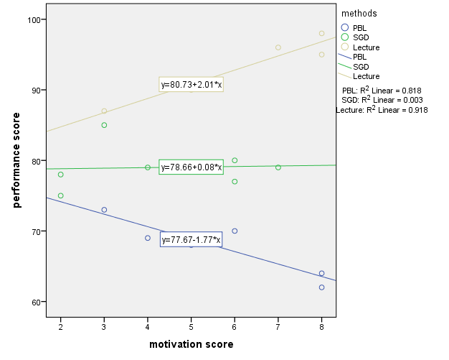

Alternative – Categorized covariate, and change to 2-way ANOVA

e.g Low Motivation as below mean, and high motivation as above mean.

Table : Descriptive Statistic

|  |  |  |
| --- | --- | --- |
|  | Low Motivation (< 5.28)  Mean (SD) | High Motivation (> 5.28)  Mean (SD) |
|  |  |  |
| PBL | 70.00 (2.65) | 65.33 (4.16) |
| SGD | 79.25 (4.19) | 78.67 (1.53) |
| Lecture | 88.50 (2.12) | 96.33 (1.53) |
|  |  |  |

Table : 2-way ANOVA Test

|  |  |  |  |  |  |  |
| --- | --- | --- | --- | --- | --- | --- |
| Source | SS | df | MS | F | p-value | Effect Size (η2)* |
|  |  |  |  |  |  |  |
| Teaching Method | 1633.86 | 2 | 816.93 | 85.06 | < 0.001 | 0.934 |
| Motivation Level | 3.20 | 1 | 3.20 | 0.334 | 0.574 | 0.027 |
| TM X ML | 106.44 | 2 | 53.22 | 5.54 | 0.020 | 0.480 |
| Error | 115.25 | 12 | 9.60 |  |  |  |
|  |  |  |  |  |  |  |
| R2 = 0.942, Adj. R2 = 0.918  *Effect Size by partial eta-squared | | | | | | |

Table : Multiple Comparison of Performance Mean Difference

|  |  |  |  |  |  |  |  |  |
| --- | --- | --- | --- | --- | --- | --- | --- | --- |
|  |  | Performance Score | | | |  |  |  |
|  |  | Adjusted Mean | SE | Adjusted Mean Different | 95% CI | F-stat (df) | p-value | Effect Size (η2)* |
|  |  |  |  |  |  |  |  |  |
| PBL | |  |  |  |  |  |  |  |
| Motivation | Low | 70.00 | 1.79 | 4.67 | (- 0.84, 10.12) | 3.40 (1, 12) | 0.090 | 0.22 |
|  | High | 65.33 | 1.79 |  |  |  |  |  |
| SGD | |  |  |  |  |  |  |  |
| Motivation | Low | 79.25 | 1.55 | 0.58 | (- 4.57, 5.74) | 0.06 (1, 12) | 0.809 | 0.01 |
|  | High | 78.67 | 1.79 |  |  |  |  |  |
| Lecture | |  |  |  |  |  |  |  |
| Motivation | Low | 88.50 | 2.19 | - 7.83 | (- 14.00, - 1.67) | 7.67 (1, 12) | 0.017 | 0.39 |
|  | High | 96.33 | 1.79 |  |  |  |  |  |
|  |  |  |  |  |  |  |  |  |
| a Adjusted mean using 2-way ANOVA  b Bonferroni adjustment for 95% CI for difference | | | | | | | | |